Store Clark

View Stock Card

Click “View Stock Card” link from menu to view stock card screen.

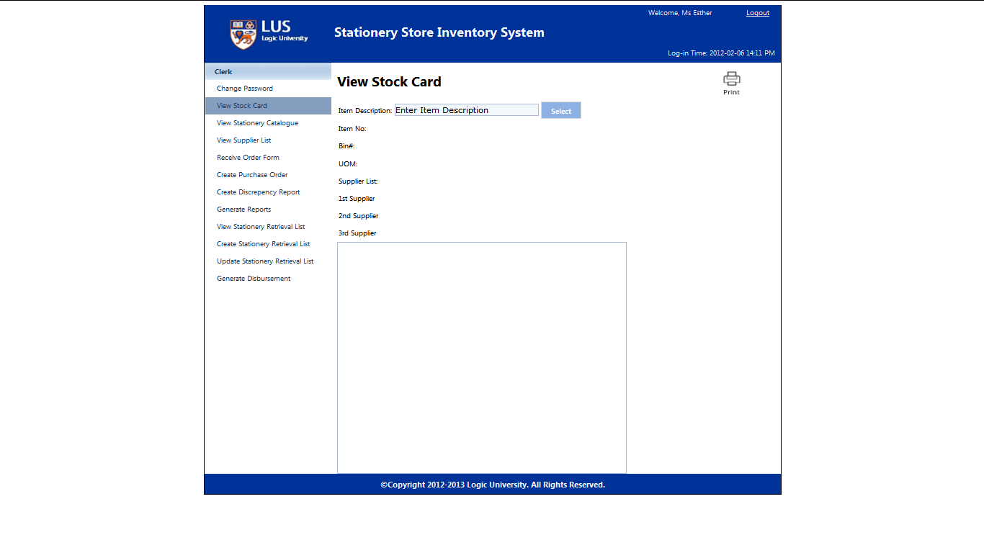

Enter the Item Description and select the desire item description.

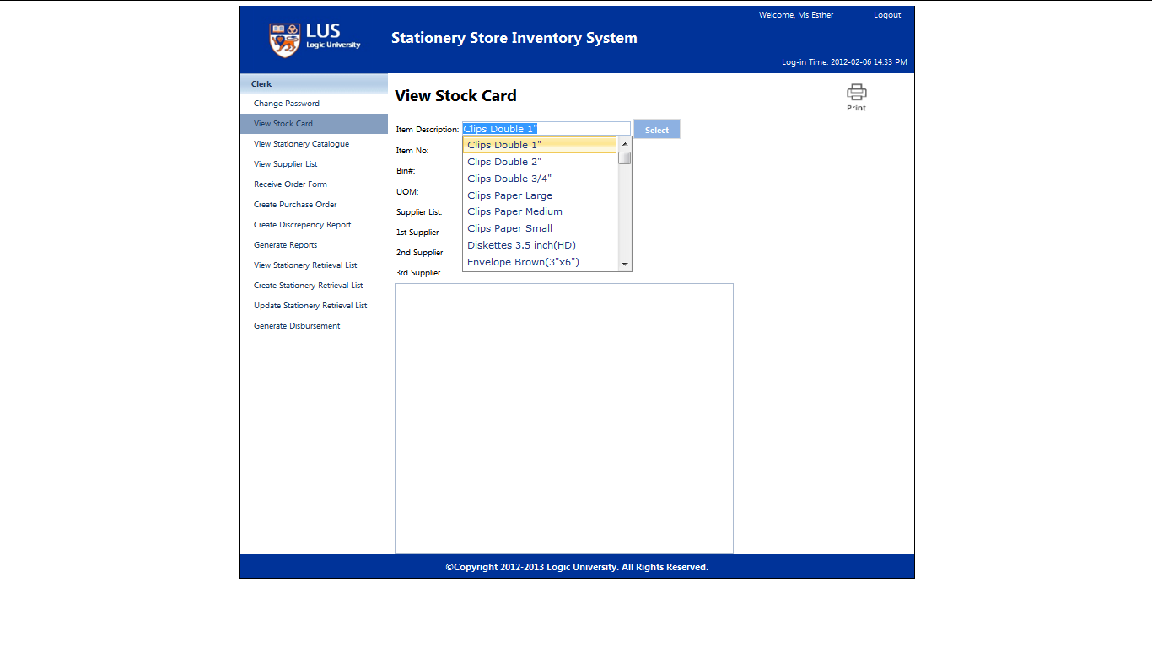

Click “Select” to view the stock card details.

